How to get Goreli Faucet?

* Download MetaMask
  + Head over to the Download Link: <https://metamask.io/download/> and follow the required steps to add MetaMask to chrome extension

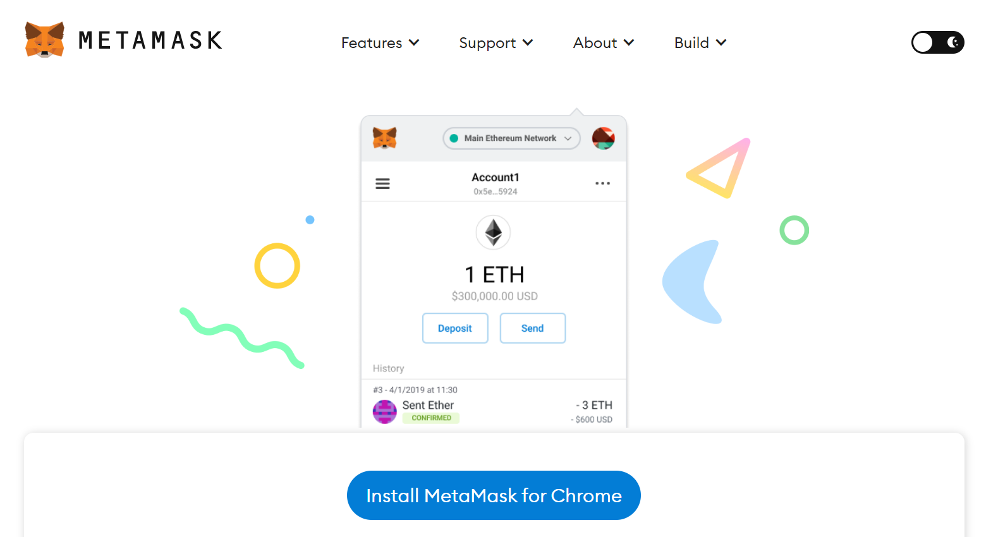

* + Once you have successfully completed all the steps to install MetaMask, click on the chrome Metamask extension icon and log in to your MetaMask account

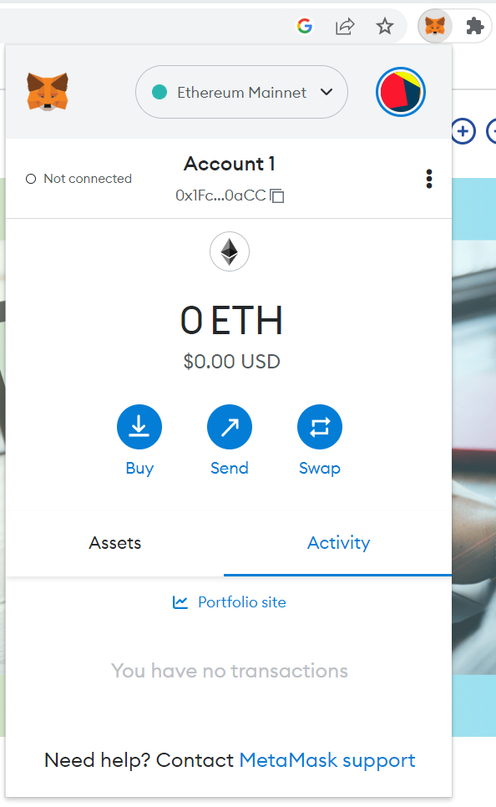

* + Click on the Ethereum Mainnet/ Networks Icon and click on the Show/Hide Test Networks, and switch on the function which says “Show Test Networks”

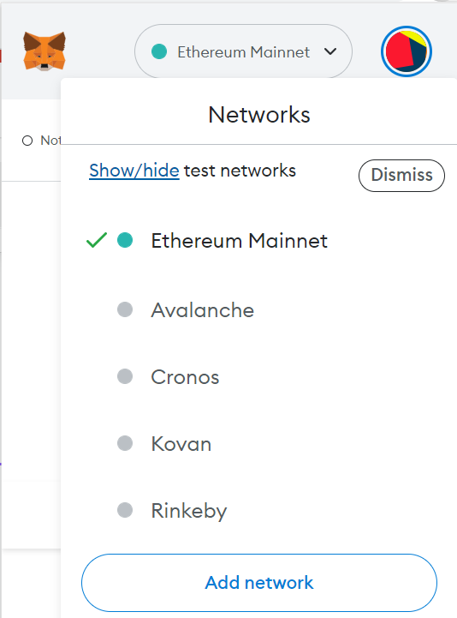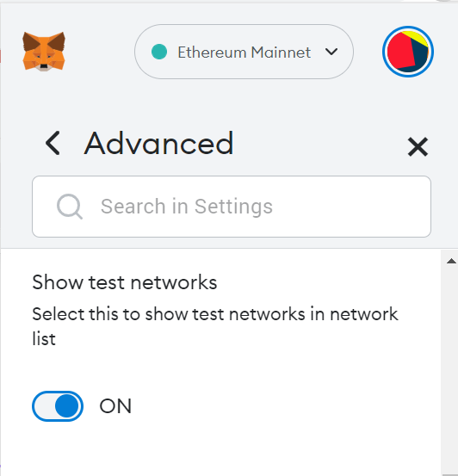

* + Click the Ethereum Mainnet Icon and this time you should get a list of Ethereum Test Networks to choose from, click on the Goreli Test Network

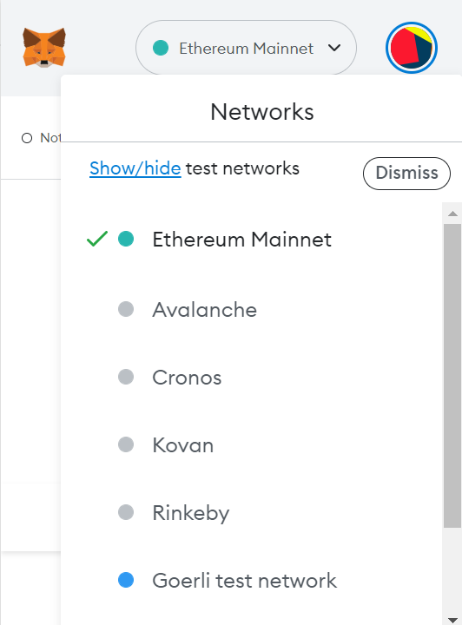

* + After heading to the Goreli Test Network, Copy the Metamask address of Account 1

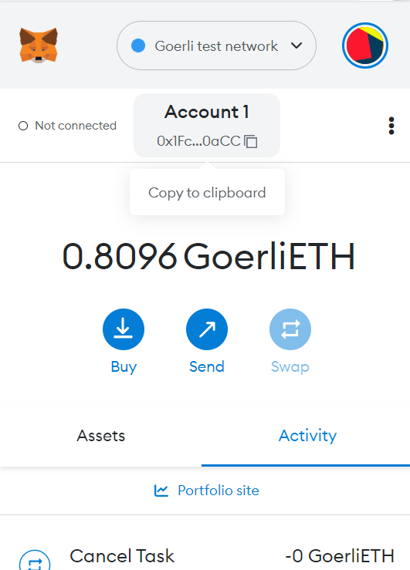

* + Head over to <https://goerli-faucet.pk910.de/> to grab some Goreli Test Faucet. Enter your Account 1 Address and Click on Start Mining, once you have mined enough Test Faucet, Click on Stop Mining and Claim your Goreli Faucet rewards.

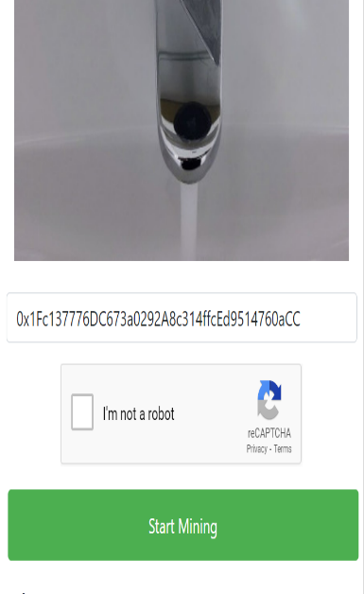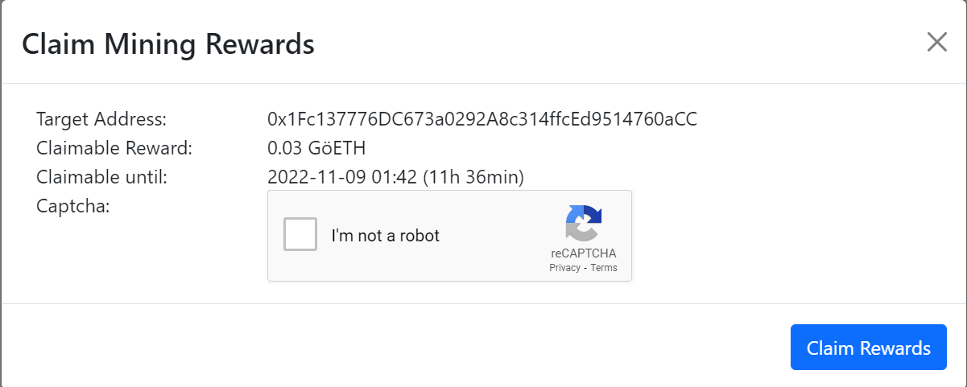

* + Once you have Test Faucet in your MetaMask account, Head over to <https://app.gelato.network/> and click on funds and deposit your test ether into the Gelato Network. MetaMask should pop up after your deposit request, click on confirm to continue with the deposit

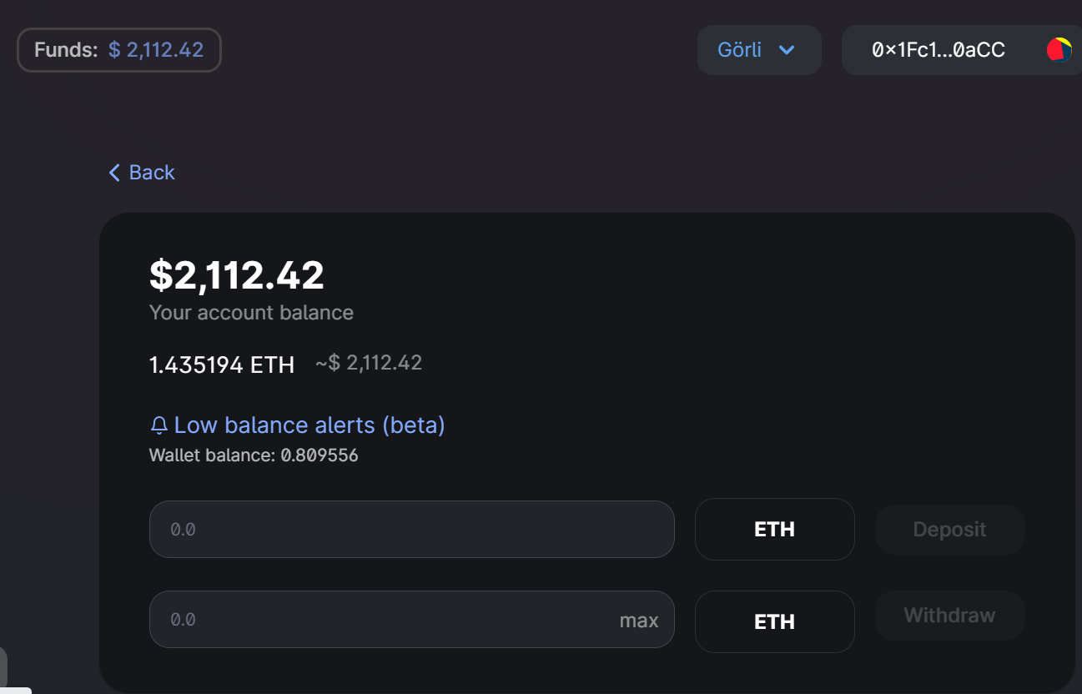

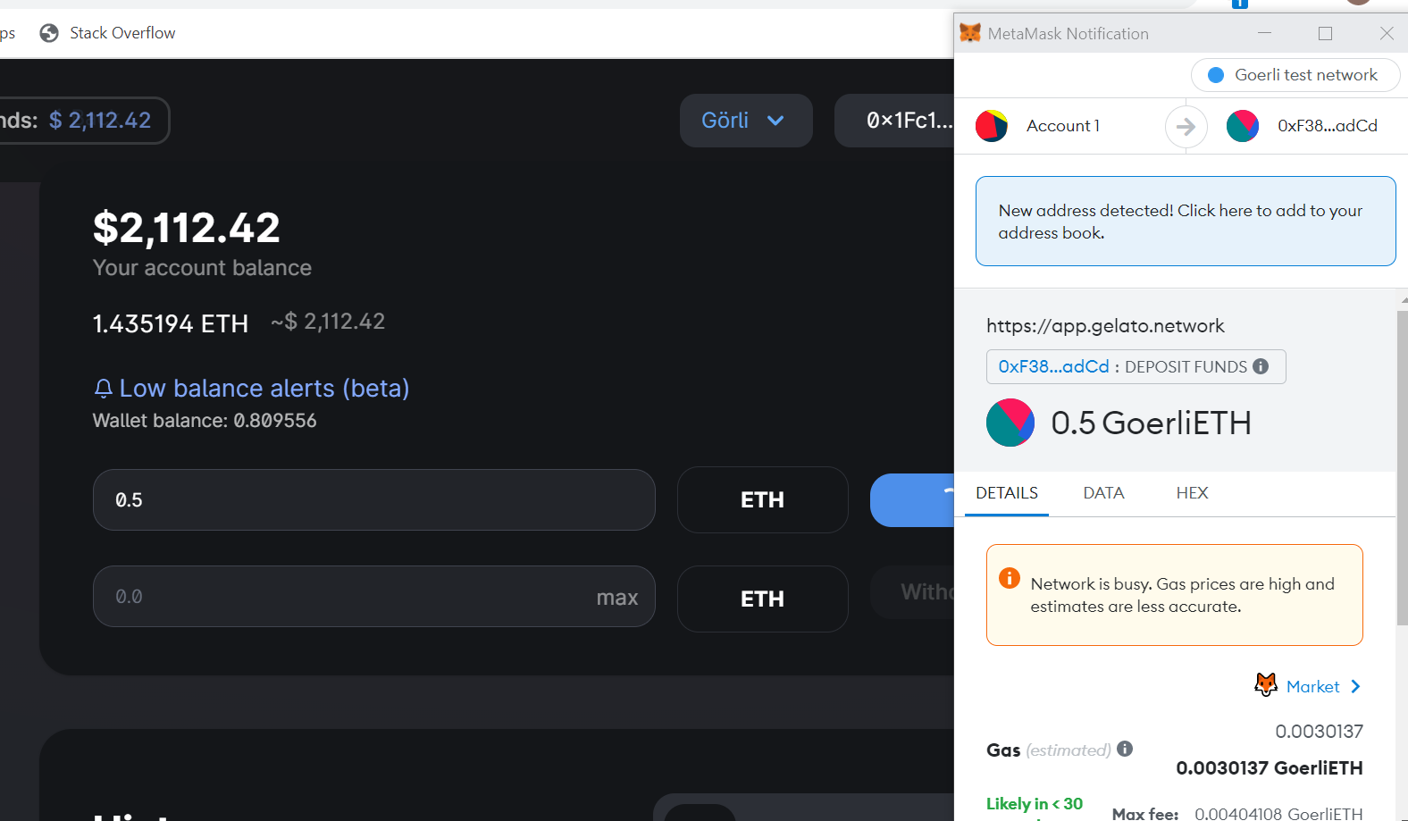

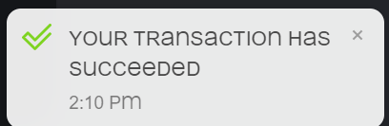

* + Upon confirmation of your Transaction (“Your transaction has succeeded”), Check your Gelato balance again. It should increase in value (in my case, it increased from $2000 to $2800)

